AI ASSISTANT LAB ASS-5.4
Ethical Foundations – Responsible AI Coding Practices

Task 1: User Data Collection & Anonymization
Prompt:
Generate a Python script to collect user data (name, age, email) and add comments explaining how to anonymize or protect this data.
Explanation:
The script collects basic user data and protects sensitive information by hashing the email instead of storing it directly.
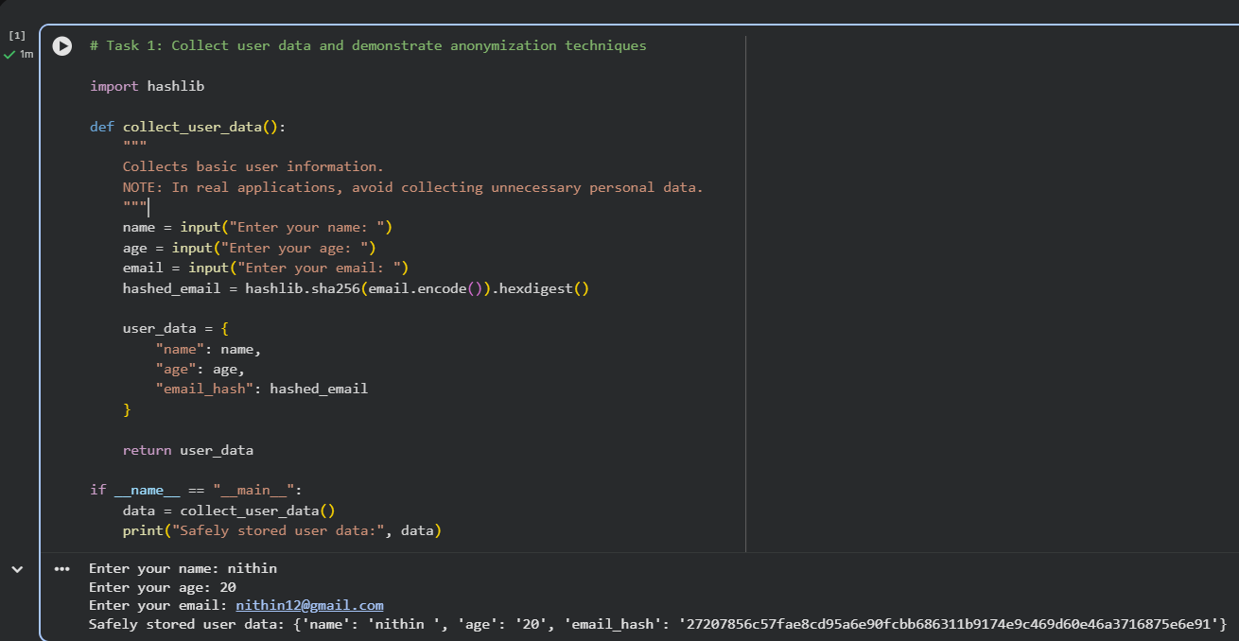
Expected Output #1:
• A script with inline Copilot-suggested code and comments explaining how to safeguard or anonymize user information (e.g., hashing emails, not storing data unencrypted).

Task 2: Sentiment Analysis with Bias Handling
Prompt:
Generate a sentiment analysis function and handle bias.
Explanation:
This function uses TextBlob to classify sentiment and includes comments on bias mitigation
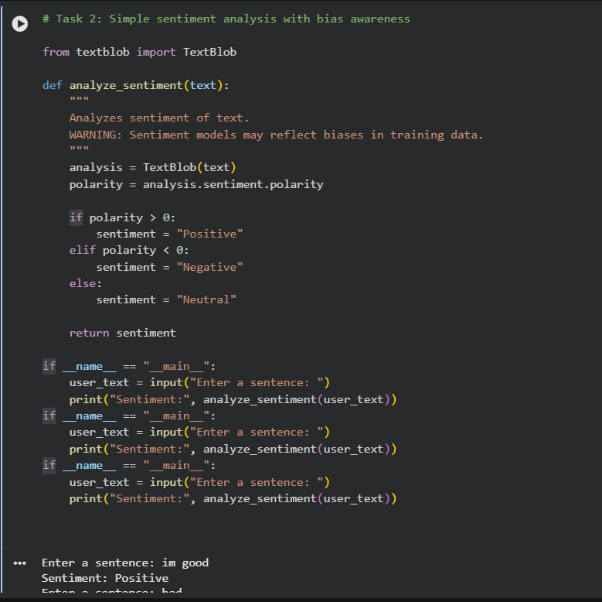
Expected Output #2:
• Copilot-generated code with additions or comments addressing bias mitigation strategies (e.g., balancing dataset, removing offensive terms).
Task Description 3:
• Use Copilot to write a Python program that recommends products based on user history. Ask it to follow ethical guidelines like transparency and fairness
Prompt:
Generate a product recommendation system following fairness and transparency.
Explanation:
Recommendations are based on user interest without favoritism.
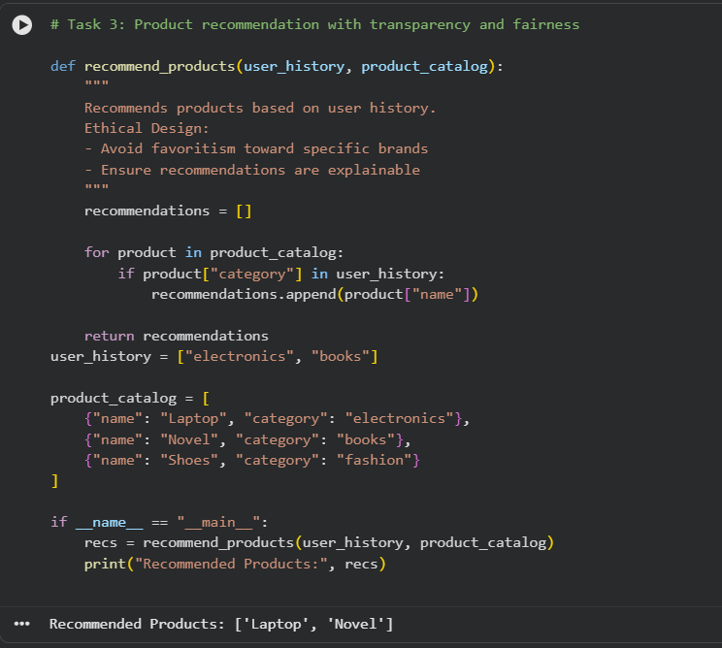
Expected Output #3:
• Copilot suggestions that include explanations, fairness checks
(e.g., avoiding favoritism), and user feedback options in the code.

Task Description #4:
• Prompt Copilot to generate logging functionality in a Python web application. Then, ask it to ensure the logs do not record sensitive information.
Prompt:
Generate logging functionality without sensitive data.
Explanation:
Logs only usernames and avoids passwords or emails.
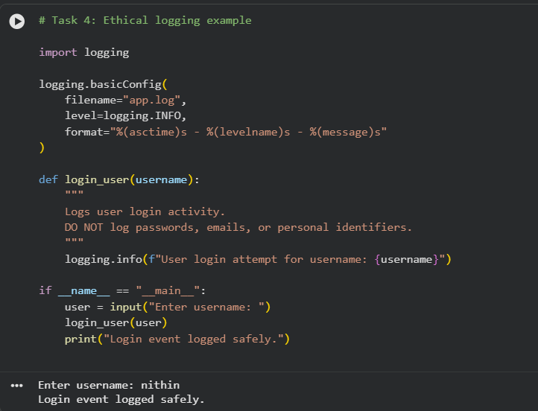
Expected Output #4:
• Logging code that avoids saving personal identifiers (e.g.,
passwords, emails), and includes comments about ethical logging
practices.

Task Description #5:
• Ask Copilot to generate a machine learning model. Then, prompt it to add documentation on how to use the model responsibly (e.g., explainability, accuracy limits).
Prompt:
Generate ML model with responsible usage documentation.
Explanation:
A simple regression model with limitations documented.
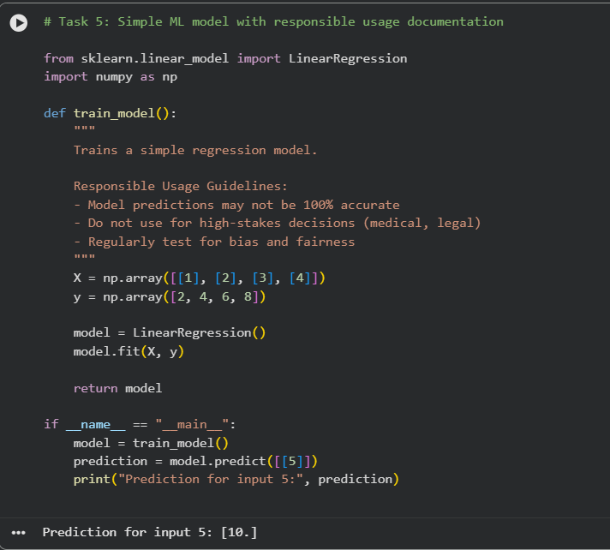
Expected Output #5:
• Copilot-generated model code with a README or inline
documentation suggesting responsible usage, limitations, and
fairness considerations.

